What is Machine Learning?
- Definition 1:
Machine Learning is the science (and art) of programming computers so they can learn from data.
- Definition 2 (Arthur Samuel, 1959):
Machine Learning is the field of study that gives computers the ability to learn without being explicitly programmed.
- Definition 3 (Tom Mitchell, 1997):
A computer program is said to learn from experience E with respect to some task T and some performance measure P, if its performance on T, as measured by P, improves with experience E.
Applications
- Image Recognition:
  - Identifies objects in images, such as facial recognition or medical imaging
- Natural Language Processing (NLP):
  - Powers chatbots, language translation, and sentiment analysis.
- Fraud Detection:
  - Detects anomalies in financial transactions or cybersecurity threats.
- Recommendation Systems:
  - Suggests products, movies, or content based on user preferences (e.g., Netflix recommendations).
- Autonomous Vehicles:
  - Enables self-driving cars to navigate safely using computer vision and ML algorithms.

Detecting tumors in brain scans
➤ Semantic segmentation – Finds the exact area of the tumor in the image.
➤ Uses: CNNs
Voice commands in an app
➤ Speech recognition – Turns spoken words into text.
➤ Uses: RNNs, Transformers
- Detecting credit card fraud
➤ Anomaly detection – Finds unusual transactions.
➤ Uses: Unsupervised learning

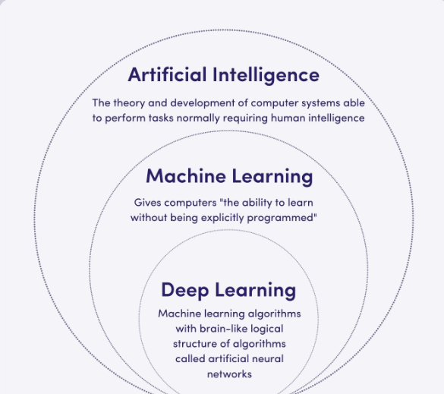

Supervised Learning
Definition:
Supervised learning is a type of machine learning where an algorithm is trained on labeled data to learn the relationship between inputs (features) and outputs (labels).
The goal is to enable the model to make accurate predictions or classifications when presented with new, unseen data.
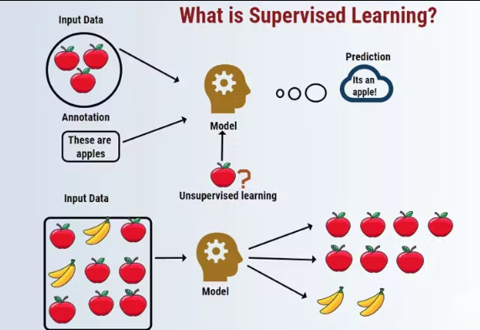

How Supervised Learning Works
- Training Phase:
- Training data includes both input features and their corresponding correct outputs (labels).
- Example: A dataset of images labeled as "apple" or "banana".
- Testing Phase:
- After training, the model is tested on unseen data to evaluate its generalization ability (how well it performs on new data).
- Error Minimization:
- The model adjusts its parameters using optimization techniques like gradient descent to reduce the loss function (a measure of prediction error).

Applications of Supervised Learning
- Spam Detection:
- Classifies emails as spam or not spam based on labeled training data.
- Fraud Detection:
- Identifies fraudulent transactions by analyzing patterns in labeled datasets.
- Image Recognition:
- Recognizes objects in images (e.g., identifying handwritten digits in postal addresses).
- Medical Diagnosis:
- Predicts diseases based on patient symptoms and medical history.
- Financial Forecasting:
- Predicts stock prices or credit risk using historical data.

supervised learning algorithms
• k-Nearest Neighbors
• Linear Regression
• Logistic Regression
• Support Vector Machines (SVMs)
• Decision Trees and Random Forests
• Neural networks2

Unsupervised Learning
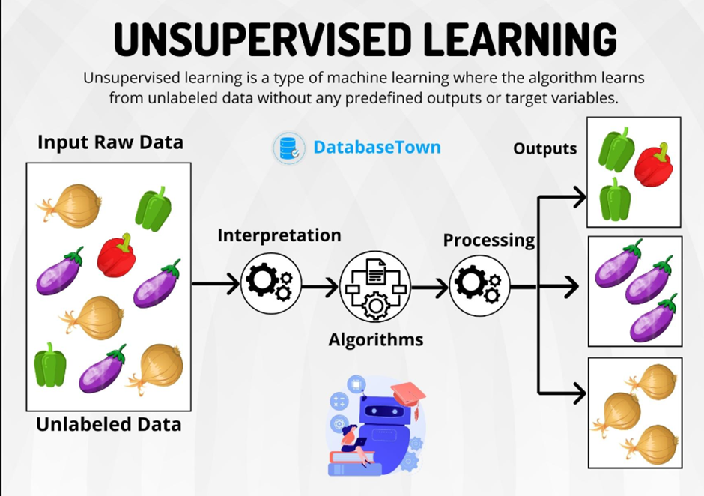

Definition:
Unsupervised learning is a type of machine learning where algorithms analyze and process unlabeled data to discover hidden patterns, structures, or relationships without any explicit guidance or predefined labels.
Unlike supervised learning, where the model learns from labeled input-output pairs, unsupervised learning operates autonomously to identify similarities and differences in the data.
Common Tasks:
- Clustering: Grouping similar data points (e.g., customer segmentation).
- Association: Finding relationships between variables (e.g., market basket analysis).
- Dimensionality Reduction: Reducing the number of features while preserving important information (e.g., PCA for visualization).

How Unsupervised Learning Works
- Input Data:
- Raw, unlabeled data is fed into the algorithm.
- Pattern Discovery:
- The algorithm uses mathematical techniques (e.g., distance measures, probability models) to identify patterns or groupings.
- Output:
- Outputs can be clusters, reduced dimensions, or associations depending on the task.

Applications of Unsupervised Learning
- Customer Segmentation:
- Grouping customers based on purchasing behavior for targeted marketing.
- Anomaly Detection:
- Identifying unusual patterns in data (e.g., fraud detection).
- Recommender Systems:
- Suggesting products based on user preferences and similarities with others.
- Image Compression:
- Reducing image size by clustering pixels with similar properties.

Common Algorithms
- Clustering Algorithms:
- K-Means
- Hierarchical Clustering
- Dimensionality Reduction Techniques:
- Principal Component Analysis (PCA)
- Association Rule Learning:
- Apriori Algorithm
- FP-Growth

Semi-Supervised Learning
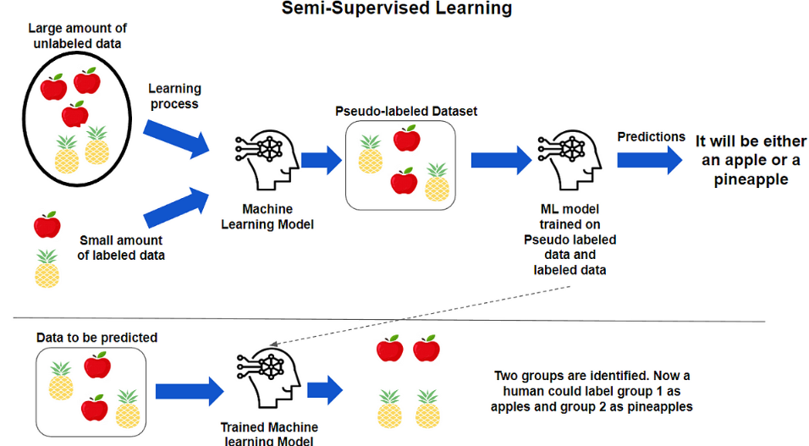
Definition:
Semi-supervised learning is a type of machine learning that uses a small amount of labeled data along with a large amount of unlabeled data to improve learning accuracy. It combines the advantages of both supervised and unsupervised learning, especially when acquiring labeled data is expensive or time-consuming.

Key Features of Semi-Supervised Learning
- Partially Labeled Data:
- Only a subset of training data is labeled; the rest is unlabeled.
- Example: A dataset containing 1,000 labeled images and 10,000 unlabeled images.
- Improved Learning Efficiency:
- Leverages the structure of unlabeled data to improve model performance compared to using labeled data alone.
- Learning Approach:
- Often involves a combination of supervised and unsupervised techniques.
- Common strategies include self-training, pseudo-labeling, and co-training.

Applications of Semi-Supervised Learning
- Speech Recognition:
- Used where labeling audio data requires expert knowledge and is costly.
- Web Content Classification:
- Classifying web pages using a small number of labeled examples.
- Medical Imaging:
- Predicting disease outcomes using few expert-labeled scans and many unlabeled ones.
- Text Categorization:
- Classifying documents or reviews using limited labeled examples.

Reinforcement Learning
Definition:
Reinforcement learning is a type of machine learning where an agent learns to make decisions by interacting with an environment to achieve a specific goal. The agent receives feedback in the form of rewards or penalties and aims to learn a policy that maximizes cumulative reward over time.
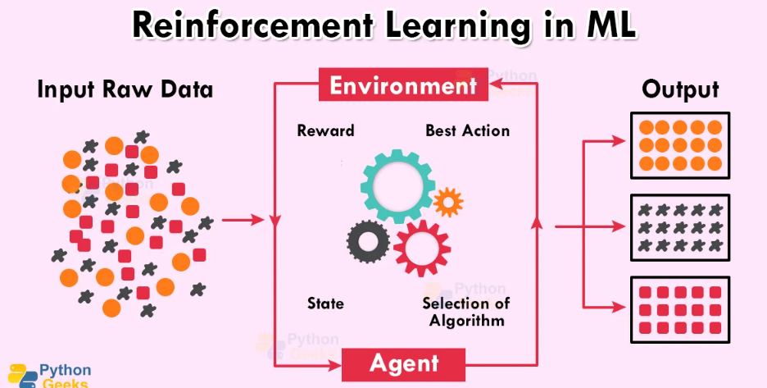

How Reinforcement Learning Works
- Initialization:
- The agent starts with no knowledge about the best actions.
- Interaction:
- The agent takes an action based on the current state.
- The environment responds with a new state and a reward.
- Learning:
- The agent updates its policy using the reward to improve future actions.
- This is repeated to learn an optimal strategy.

Applications of Reinforcement Learning
- Game Playing:
- Training agents to play games like Chess, Go, or video games.
- Robotics:
- Teaching robots to walk, grasp, or navigate autonomously.
- Autonomous Vehicles:
- Learning to drive or navigate through traffic.

Common Algorithms
- Q-Learning
- Deep Q-Networks (DQN)
- SARSA
- Policy Gradient Methods
- Actor-Critic Models

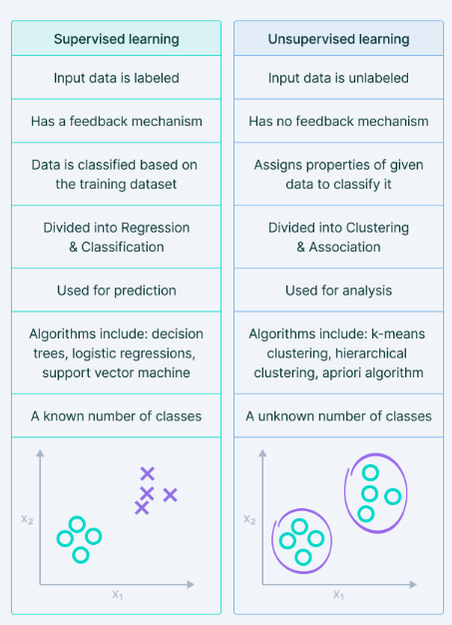
Batch Learning vs. Online Learning in Machine Learning
Batch learning and online learning are two distinct approaches to training machine learning models, differing primarily in how they handle data and update the model.
1. Batch Learning
- Definition:
Batch learning involves training a machine learning model on the entire dataset (or large subsets of it) at once. The model is trained offline and does not update incrementally as new data arrives.
- Characteristics:
  - Processes all available data at once or in large batches.
  - Requires the entire dataset to be available before training begins.
  - Computationally intensive and time-consuming, especially for large datasets.
  - Once trained, the model is deployed and remains static until retrained with updated data.
- Advantages:
  - Efficient for large datasets when computational resources are sufficient.
  - Produces stable models as it learns from the entire dataset at once.
- Disadvantages:
  - Not suitable for scenarios where data arrives continuously or changes over time.
  - Requires retraining from scratch when new data becomes available.
- Example:
  - Training a spam email classifier using a large historical dataset of labeled emails. The model is trained offline and deployed to classify future emails24.
2. Online Learning
- Definition:
Online learning trains a machine learning model incrementally by processing one data point (or a small batch) at a time. It updates the model continuously as new data arrives.
- Characteristics:
  - Processes data sequentially, one instance or small batch at a time.
  - Suitable for real-time applications where data is constantly generated.
  - Adapts to changes in the data distribution over time (concept drift).
- Advantages:
  - Efficient for real-time or streaming data scenarios.
  - Can adapt quickly to new patterns in the data without retraining from scratch.
- Disadvantages:
  - May be less stable due to frequent updates, especially with noisy data.
  - Requires careful tuning of learning rates to avoid overfitting or underfitting.
- Example:
  - Fraud detection in financial transactions: The model processes each transaction as it occurs and updates itself to detect emerging fraud patterns in real-time
1. Instance-Based Learning
- Definition:
Instance-based learning, also known as lazy learning, does not create an explicit model during training. Instead, it memorizes the training data and makes predictions by comparing new data points with stored instances.
- How It Works:
  - Stores all (or a subset of) the training data.
  - When a new input is provided, it calculates similarities (e.g., distances) between the new input and stored instances.
  - Predictions are made based on the most similar stored examples (e.g., majority voting in classification).
- Key Characteristics:
  - No explicit generalization; predictions rely on local comparisons.
  - Requires retaining training data for inference.
  - Computationally expensive at prediction time due to similarity calculations.
- Example Algorithms:
  - k-Nearest Neighbors (k-NN)
  - Radial Basis Function Networks (RBF)
- Advantages:
  - Simple to implement and adapt to new data.
  - Effective for problems with complex relationships or irregular patterns.
- Disadvantages:
  - High memory usage as it stores training data.
  - Slow prediction time, especially for large datasets.
  - Sensitive to irrelevant or noisy features.
- Example Use Case:
  - Medical Diagnosis: Predicting a patient's condition by finding similar cases in historical medical records.
2. Model-Based Learning
- Definition:
Model-based learning, also known as eager learning, involves creating a mathematical model during training that generalizes the relationships between input features and output labels.
- How It Works:
  - Learns a function or model (e.g., linear equation, decision boundary) from the training data.
  - The model is used to make predictions on new inputs without needing the original training data.
- Key Characteristics:
  - Generalizes patterns in the data into a compact representation (model).
  - Once trained, the model is independent of the training data.
  - Faster predictions since inference uses the pre-trained model.
- Example Algorithms:
  - Linear Regression
  - Logistic Regression
  - Support Vector Machines (SVMs)
  - Neural Networks
- Advantages:
  - Efficient at prediction time since it doesn't rely on stored instances.
  - Compact representation of knowledge through learned parameters.
  - Handles large datasets effectively during inference.
- Disadvantages:
  - Requires careful tuning of hyperparameters during training.
  - May struggle with irregular patterns if the chosen model is too simple (underfitting).
- Example Use Case:
  - Stock Market Prediction: Using linear regression to predict future stock prices based on historical trends and economic indicators.

Batch Learning
Definition:
Batch learning involves training a machine learning model on the entire dataset (or large subsets of it) at once. The model is trained offline and does not update incrementally as new data arrives.
Key Points:
- Trains on all data at once.
- Needs full dataset before starting.
- Time-consuming and resource-heavy.
- Model stays the same until retrained.
- Example: Spam email classifier trained on historical data.
Pros:
- Stable and accurate when enough data is available.
- Efficient if resources are sufficient.
Cons:
- Can't handle real-time data.
- Needs retraining for new data.

Online Learning
Definition:
Online learning trains a machine learning model incrementally by processing one data point (or a small batch) at a time. It updates the model continuously as new data arrives.
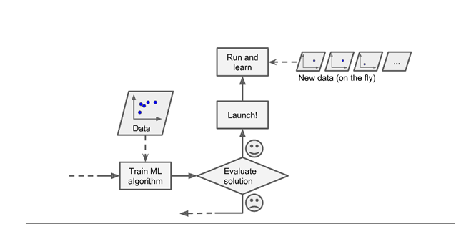
Key Points:
- Learns from data one point or small batch at a time.
- Good for real-time or streaming data.
- Adapts to new data over time.
- Example: Real-time fraud detection.
Pros:
- Works with continuously changing data.
- No need for retraining from scratch.
Cons:
- Frequent updates may cause instability.
- Needs careful tuning to avoid overfitting.

Instance-Based Learning
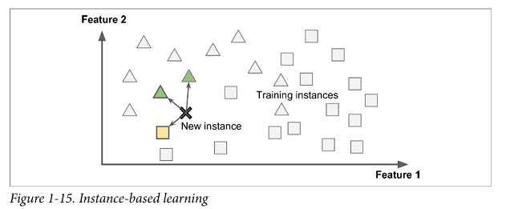
Definition:
Instance-based learning, also known as lazy learning, does not create an explicit model during training. Instead, it memorizes the training data and makes predictions by comparing new data points with stored instances.
How It Works:
- Stores training data.
- Compares new input with stored examples.
- Predicts based on most similar examples.
Key Characteristics:
- No generalization; depends on comparisons.
- Needs full data for prediction.
- Slow at prediction time.
Algorithms:
- k-NN
- RBF Networks
Pros:
- Easy to implement.
- Works well with complex or irregular data.
Cons:
- Needs a lot of memory.
- Slow for large datasets.
- Sensitive to noisy features.
Example Use Case:
Medical diagnosis by comparing with past patient records.

Model-Based Learning
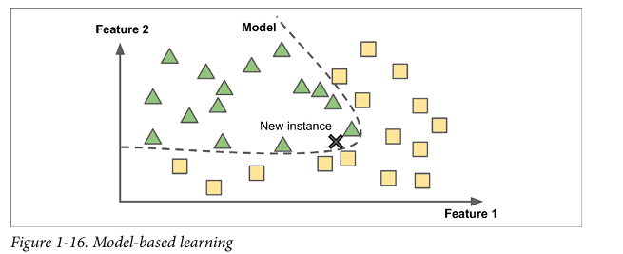
Definition:
Model-based learning, also known as eager learning, involves creating a mathematical model during training that generalizes the relationships between input features and output labels.
How It Works:
- Learns a general model (like a formula).
- Uses the model to predict new data without storing old data.
Key Characteristics:
- Generalizes patterns into a model.
- Fast prediction.
- Doesn’t need training data after learning.
Algorithms:
- Linear Regression
- Logistic Regression
- SVM
- Neural Networks
Pros:
- Fast at prediction.
- Efficient and compact.
- Good for large datasets.
Cons:
- Needs tuning of model settings.
- Can underfit if model is too simple.
Example Use Case:
Stock price prediction using linear regression on historical data.

Overfitting
- Occurs when: A model is too complex and fits the training data too closely.
- Reasons:
  - • Model is too complex for the amount of data.
  - • Too many features (some may be irrelevant).
  - • Noisy or small dataset, so the model learns random patterns
- Examples:
  - A model trained to recognize dogs might identify grass as a key feature if most images show dogs in parks.
  - A model predicting academic performance might overfit if it is trained on a dataset from a specific demographic.
- Prevention:
  - • Use a simpler model (e.g., linear instead of polynomial).
  - • Remove irrelevant features (feature selection).
  - • Collect more training data.
  - • Clean the data (remove outliers, fix mistakes).
  - • Apply regularization to limit model flexibility.

Underfitting
- Occurs when: A model is too simple and fails to capture the underlying patterns.
- Reasons:
  - • Model is too simple to capture patterns in the data.
  - • Important features may be missing or ignored.
  - • Too much regularization (model is too restricted).
- Examples:
  - A simple linear model might not capture complex relationships in the data.
  - A model that fails to account for important features in the data.
- Prevention:
  - Increase Model Complexity
  - More Training Data
  - Hyperparameter Tuning
- Key Differences
Characteristics | Overfitting | Underfitting
Model Complexity | Too Complex | Too Simple
Training Performance | Good | Poor
Test Performance | cc | Poor
Bias-Variance Tradeoff | High Variance | High Bias
Solution | Reduce Complexity, Regularization | Increase Complexity, More Data

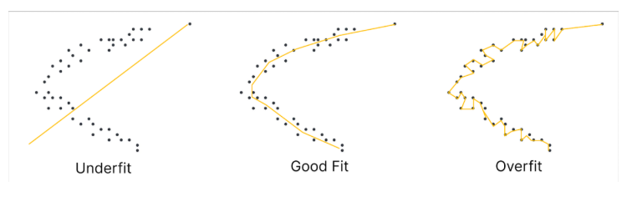

Challenges in Machine Learning

1. Data-Related Challenges
- Lack of Quality Data: Bad or small datasets can make the model perform poorly.
- Non-Representative Data: If the data doesn’t cover different real-world cases, the model may be biased.
- Data Bias: If some groups are over- or under-represented, the model may give unfair results.
- Privacy and Security: It’s hard to protect user data and follow laws like GDPR, especially in areas like healthcare.

2. Model-Related Challenges
- Overfitting: The model learns the training data too well and fails on new data.
  - Fix: Use regularization, cross-validation, or dropout.
- Underfitting: The model is too simple and misses important patterns.
  - Fix: Make the model more complex or improve features.
- Interpretability: Complex models (like deep learning) are hard to understand.
- Algorithm Selection: Picking the right algorithm needs knowledge and testing.

3. Operational Challenges
- Scalability: Big models need a lot of computer power and storage.
- Real-Time Processing: Some tasks (like fraud detection) need fast, real-time predictions.
- Deployment & Maintenance: Putting models into production and keeping them accurate over time is tough (e.g., dealing with changing data).

4. Ethical and Societal Challenges
- Bias & Fairness: Models can learn unfair behavior from biased data.
- Ethical Concerns: Some uses (like face recognition) raise privacy and misuse issues.
- Accountability: It’s hard to decide who is responsible if an ML system makes a wrong or harmful decision.

✅ 1. Insufficient Quantity of Training Data
- Reason: The model doesn’t get enough examples to learn patterns.
- Example: A child sees only one apple — not enough to learn what apples really look like.
- Prevention: Collect more data to train the model.

✅ 2. Nonrepresentative Training Data
- Reason: The data doesn’t represent the real-world situation.
- Example: Training a flower app with only pictures from the internet, not real mobile photos.
- Prevention: Use data that is similar to real usage, and make sure it’s diverse and balanced.

✅ 3. Poor-Quality Data
- Reason: Data is noisy, contains errors, outliers, or missing values.
- Example: Wrong age entries, missing fields, or sensor errors.
- Prevention:
  - Clean the data (fix errors).
  - Remove or fix outliers.
  - Handle missing values (fill in, ignore, or use smarter techniques).

✅ 4. Irrelevant Features
- Reason: The model uses unhelpful inputs that confuse learning.
- Example: Using a person’s name to predict their income.
- Prevention:
  - Do feature selection (keep useful features).
  - Use feature engineering to create better features.
  - Remove features that don’t contribute.

✅ 5. Overfitting the Training Data
- Reason: The model is too complex and learns even the noise.
- Example: A model says "countries with a 'w' are always happy" — not a real pattern.
- Prevention:
  - Use a simpler model.
  - Clean and reduce noise in data.
  - Use regularization to limit overfitting.
  - Add more data.

✅ 6. Underfitting the Training Data
- Reason: The model is too simple to learn the real patterns.
- Example: Predicting life satisfaction with a straight line when the actual pattern is curved.
- Prevention:
  - Use a more powerful model.
  - Do better feature engineering.
  - Reduce regularization so the model can learn more.

✅ 7. Testing and Validating
- Reason: Need to check how well the model performs on new data.
- Example: A model works great on training data but fails on new examples.
- Prevention:
  - Split data into training set and test set.
  - Measure generalization error to check real-world performance.
  - Use validation sets to fine-tune models.

✅ 8. Hyperparameter Tuning and Model Selection
- Reason: Need to choose the best model and best settings (hyperparameters).
- Example: Choosing between a linear and a polynomial model.
- Prevention:
  - Use holdout validation (train on part of data, test on another).
  - Choose the model that performs best on the validation set.
  - Finally, test the chosen model on the test set.

✅ 9. Data Mismatch
- Reason: Training data and real-world (test/validation) data are very different.
- Example: Training on clean web images but testing on blurry phone images.
- Prevention:
  - Make sure test and validation sets match real-world data.
  - Use a train-dev set to find out if the problem is due to overfitting or mismatch.
  - If the model does well on the training and train-dev set but poorly on validation, the issue is data mismatch.

Concept Learning

📘 Definition
The Candidate Elimination Algorithm is a supervised learning algorithm used in concept learning. It finds all hypotheses that are consistent with the training examples by maintaining a version space bounded by the most specific (S) and general (G) hypotheses.
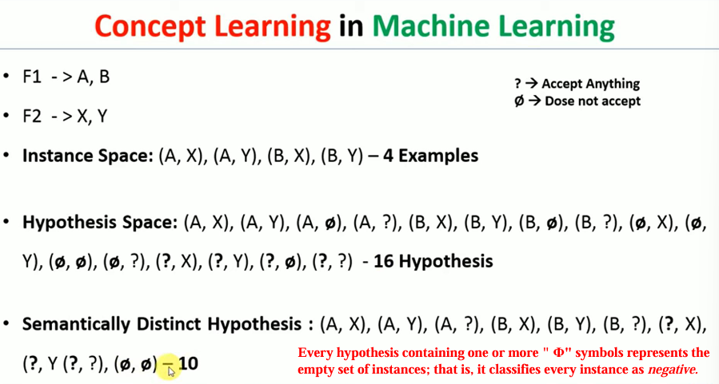

🎯 Goal
- To identify the target concept (c) by eliminating inconsistent hypotheses.
- Learn a hypothesis h ∈ H such that:
  - For every training example (x, c(x)),
h(x) = c(x)
- Final version space contains only hypotheses consistent with all observed examples.

⚙️ Working (Step-by-Step)
- Initialize:
  - S ← Most specific hypothesis (e.g., ⟨∅, ∅, ∅, ...⟩)
  - G ← Most general hypothesis (e.g., ⟨?, ?, ?, ...⟩)
- For each training example:
  - If positive (c(x) = 1):
    - Remove any hypothesis from G that does not match the example.
    - Generalize S minimally so it matches the example.
  - If negative (c(x) = 0):
    - Remove any hypothesis from S that matches the example.
    - Specialize G minimally to exclude the example.
- Ensure:
  - All hypotheses in S are more specific than those in G.
  - All hypotheses in the version space lie between S and G.
- Stop when all training examples are processed.

.

Definition:
The Find-S algorithm is a simple concept learning algorithm used to find the most specific hypothesis that fits all the positive examples in a dataset. It starts with the most specific hypothesis and generalizes it iteratively to include all positive examples while ignoring negative examples.
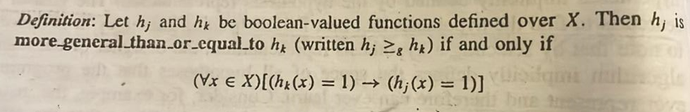
Steps:
- Initialize the hypothesis as the most specific (e.g., all attributes set to null or empty).
- For each positive example:
  - Generalize the hypothesis minimally to include the example.
- Ignore negative examples.
- The final hypothesis is the most specific one that fits all positive examples.

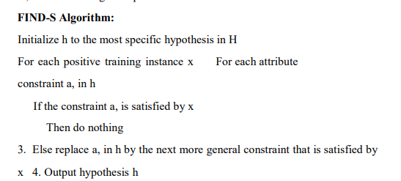
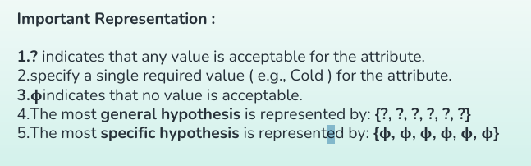
Definition:

The Candidate Elimination Algorithm (CEA) is a supervised learning algorithm used for concept learning. It maintains a version space, which is the set of all hypotheses consistent with the training data, and refines this space iteratively using both positive and negative examples. It uses two boundaries:
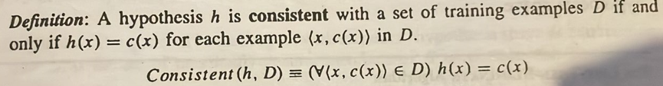
- Specific Boundary (S): The most specific hypotheses that fit the data.
- General Boundary (G): The most general hypotheses that fit the data.
Steps:
- Initialize:
  - Set SS to the most specific hypothesis (e.g., all attributes null).
  - Set GG to the most general hypothesis (e.g., all attributes as wildcards).
- Process each training example:
  - For a positive example:
    - Generalize SS minimally to include the example.
    - Remove inconsistent hypotheses from GG.
  - For a negative example:
    - Specialize GG minimally to exclude the example.
    - Remove inconsistent hypotheses from SS.
- Refine SS and GG until they converge or no further refinement is possible.

Feature | Find-S Algorithm | Candidate Elimination Algorithm
Learning Type | Learns only from positive examples | Learns from both positive and negative examples
Output Hypothesis | Most specific hypothesis | Set of all consistent hypotheses (version space)
Initialization | Starts with the most specific hypothesis | Starts with both specific and general boundaries
Flexibility | Limited; ignores negative examples | Flexible; refines boundaries based on all data
Use Case Examples | Simple concept learning | Complex concept learning with noisy datasets
Advantages | Easy to implement, computationally efficient | Comprehensive exploration of hypothesis space
Disadvantages | Ignores negative data, prone to overfitting | Computationally expensive for large datasets

MNIST Dataset Overview:
- The MNIST dataset contains 70,000 handwritten digit images (28x28 pixels each).
- Each image is labeled with the digit it represents (0 to 9).
- It’s a widely used dataset for testing machine learning classification algorithms.

Data Structure:
- Shape of Data:
  - X.shape = (70000, 784)
    - 70,000 images, each with 784 features (28x28 pixels flattened).
  - y.shape = (70000,)
    - 70,000 labels corresponding to the images.
- Data Format:
  - Data (X): Each row represents an image (flattened 28x28).
  - Target (y): The label of the digit in the image (0-9).

Code to Access the Dataset:
- Fetch MNIST using Scikit-Learn:
- from sklearn.datasets import fetch_openml
- mnist = fetch_openml('mnist_784', version=1)

- Check the keys of the dataset:
- mnist.keys() # ['data', 'target', 'feature_names', 'DESCR', ...]

- Get the data and target:
- X, y = mnist["data"], mnist["target"]

Visualizing an Image:
- To view an image from the dataset:
- import matplotlib.pyplot as plt
- some_digit = X[0]
- some_digit_image = some_digit.reshape(28, 28)
- plt.imshow(some_digit_image, cmap="binary")
- plt.axis("off")
- plt.show()
This will show the first digit in the dataset.

Target Labels:
- Labels in y are strings. To use them for machine learning, convert them to integers:
- y = y.astype(np.uint8)

Training and Test Split:
- The dataset is already split into:
  - Training set: First 60,000 images
  - Test set: Last 10,000 images
- Split the dataset as:
- X_train, X_test, y_train, y_test = X[:60000], X[60000:], y[:60000], y[60000:]

Shuffling:
- The dataset is shuffled by default for better generalization.
- Shuffling ensures that learning algorithms don’t get biased by similar instances in a row.

Training a Binary Classifier:
- Task: Identify whether an image represents the digit 5 (binary classification: 5 or not-5).
- Create Target Vectors:
  - For the training set:
  - y_train_5 = (y_train == 5) # True for 5s, False for other digits
  - For the test set:
  - y_test_5 = (y_test == 5)

Using a Classifier:
- Classifier Chosen: Stochastic Gradient Descent (SGD) classifier.
- Training the Classifier:
- from sklearn.linear_model import SGDClassifier
- sgd_clf = SGDClassifier(random_state=42)
- sgd_clf.fit(X_train, y_train_5)
- Prediction:
- sgd_clf.predict([some_digit]) # Predicts if the image is a 5 or not.

Performance Measures:
- Evaluating Accuracy: Use cross-validation for a better evaluation.
- Cross-validation with 3 folds:
- from sklearn.model_selection import cross_val_score
- cross_val_score(sgd_clf, X_train, y_train_5, cv=3, scoring="accuracy")
  - Example results:
array([0.96355, 0.93795, 0.95615])
  - Accuracy above 93%.

Comparison with a Dummy Classifier:
- Dummy Classifier: A classifier that always predicts "not-5" for all images.
  - Code:
  - class Never5Classifier(BaseEstimator):
  - def fit(self, X, y=None):
  - return self
  - def predict(self, X):
  - return np.zeros((len(X), 1), dtype=bool)
  - Cross-validation:
  - cross_val_score(never_5_clf, X_train, y_train_5, cv=3, scoring="accuracy")
  - Result: Over 90% accuracy.
  - Why? Because only about 10% of images are 5s. Predicting "not-5" all the time still gives a high accuracy.

🔹 Binary Classification (Simplified)

✅ What is Binary Classification?
- It is a type of supervised learning.
- The model learns from labeled data to predict one of two classes (e.g., Yes/No, True/False, Positive/Negative).
- Examples:
  - Medical: Sick or Healthy
  - Email: Spam or Not Spam
  - Bank: Loan approved or rejected

✅ Key Terms
Term | Meaning
True Positive (TP) | Model correctly predicts a positive result (e.g., sick → sick)
False Positive (FP) | Model wrongly predicts positive (e.g., healthy → sick)
True Negative (TN) | Model correctly predicts a negative result (e.g., healthy → healthy)
False Negative (FN) | Model wrongly predicts negative (e.g., sick → healthy)

✅ Accuracy Formula
To measure how well the model performs:
Accuracy=TP+TNTP+FP+TN+FN\text{Accuracy} = \frac{TP + TN}{TP + FP + TN + FN}

✅ Common Algorithms Used
- Logistic Regression
- Support Vector Machines (SVM)
- Decision Trees
- Random Forest
- Naive Bayes
- K-Nearest Neighbors (KNN)
- Neural Networks

A confusion matrix is a table used to evaluate the performance of a classification model. It provides a detailed breakdown of the model's predictions compared to the actual outcomes, helping to identify where the model is making errors. The matrix is particularly useful for binary and multi-class classification problems.
Key Components of a Confusion Matrix
The confusion matrix consists of four main components:
- True Positive (TP): The model correctly predicts a positive outcome.
- True Negative (TN): The model correctly predicts a negative outcome.
- False Positive (FP): The model incorrectly predicts a positive outcome (Type I error).
- False Negative (FN): The model incorrectly predicts a negative outcome (Type II error)¹².
Metrics Derived from the Confusion Matrix
Several important metrics can be derived from the confusion matrix to evaluate the performance of a classification model:
- Accuracy: The ratio of correctly predicted instances to the total instances. Accuracy = (TP + TN) / (TP + TN + FP + FN)
- Precision: The ratio of true positive predictions to the total positive predictions made by the model. Precision = TP / (TP + FP)
- Recall: The ratio of true positive predictions to the sum of true positive and false negative predictions. Recall = TP / (TP + FN)
- F1-Score: The harmonic mean of precision and recall. F1-Score = 2 * (Precision * Recall) / (Precision + Recall)
- Specificity: The ratio of true negative predictions to the sum of true negative and false positive predictions. Specificity = TN / (TN + FP)

📊 Performance Measures in Classification

✅ 1. Accuracy
- Definition: Ratio of correct predictions to total predictions.
- Problem: Not reliable for skewed datasets (e.g., if 90% of images are not “5”, a model predicting “not 5” always gets 90% accuracy).

🔄 2. Cross-Validation
- Use cross_val_score() for quick scoring, or manually implement with StratifiedKFold for more control.
- Stratified sampling ensures each fold has representative class ratios.

🧮 3. Confusion Matrix
- Rows = actual class; Columns = predicted class.
- Key terms:
  - True Positive (TP): Correctly predicted “5”
  - False Positive (FP): Wrongly predicted “5”
  - True Negative (TN): Correctly predicted “not 5”
  - False Negative (FN): Missed a “5”
Predicted
0 | 1
Actual ----------------
0 | TN | FP
1 | FN | TP

📌 4. Precision and Recall
- Precision = TP / (TP + FP) → Of predicted 5s, how many were correct?
- Recall = TP / (TP + FN) → Of actual 5s, how many were detected?

🔄 5. F1 Score
- Harmonic mean of precision and recall.
- F1 = 2 × (precision × recall) / (precision + recall)
- Best when you want a balance between precision and recall.

⚖️ 6. Precision/Recall Trade-off
- Higher threshold → Higher precision, lower recall.
- Lower threshold → Higher recall, lower precision.
- Use decision_function() to get prediction scores and customize threshold.

📈 7. Precision-Recall Curve
- Plot precision and recall against thresholds using:
- from sklearn.metrics import precision_recall_curve
- precisions, recalls, thresholds = precision_recall_curve(y_train_5, y_scores)

Multiclass Classification
- Binary classifiers are used to distinguish between two classes only.
Example algorithms: Logistic Regression or Support Vector Machine (SVM) classifiers.
- Multiclass classifiers (also called multinomial classifiers) can distinguish between more than two classes.
Example algorithms: SGD classifiers, Random Forest classifiers, and Naive Bayes classifiers.

Strategies to Perform Multiclass Classification Using Binary Classifiers

1) One-versus-the-rest (OvR) Strategy (also called One-versus-all)
- Suppose you want to classify images of digits (0 to 9), so 10 classes.
- You train 10 binary classifiers, one for each digit:
  - 0 vs not-0
  - 1 vs not-1
  - 2 vs not-2
  - ...
  - 9 vs not-9
- To classify an image:
  - Each classifier gives a decision score.
  - You choose the class with the highest score.
✅ Example using MNIST (10 classes):
from sklearn.svm import SVC
svm_clf = SVC()
svm_clf.fit(X_train, y_train)
svm_clf.predict([some_digit]) # Predicts a digit like 5
To see the decision scores:
some_digit_scores = svm_clf.decision_function([some_digit])

2) One-versus-one (OvO) Strategy
- You train a binary classifier for every pair of digits:
  - 0 vs 1
  - 0 vs 2
  - ...
  - 8 vs 9
- If there are N classes, you need to train N × (N–1)/2 classifiers.
  - For MNIST (10 digits) → 45 classifiers
- To classify an image:
  - You run the image through all 45 classifiers.
  - The class that wins the most duels is the final prediction.
🧠 SVM classifiers scale poorly with big training sets, so OvO is preferred with SVM.

Multilabel Classification
- A classifier outputs multiple binary labels (0 or 1) for each instance.
- Example: A face recognition system trained to detect Alice, Bob, and Charlie.
- If a photo has Alice and Charlie, the output is:
➤ [1, 0, 1] → Alice: yes, Bob: no, Charlie: yes.
- Each label is independent (can be yes/no for each class).
- This is called a multilabel classification system.

Multioutput Classification
- A generalization of multilabel classification.
- Each output can have more than two values (not just binary).
- Example: A system that removes noise from images.
  - Input: Noisy digit image.
  - Output: Clean digit image (an array of pixel intensities from 0 to 255).
- So, each pixel is a label, and each label can have multiple values.
- This makes it a multioutput classification system.

✅ Key Differences
- Multilabel Classification:
  - Output = Multiple binary labels
  - Example: [1, 0, 1] for people in a photo
- Multioutput Classification:
  - Output = Multiple labels, each can have multiple values
  - Example: Image pixels ranging from 0 to 255

Appropriate Problems for Decision Tree Learning
- Instances are represented by attribute-value pairs
  - Each example (or instance) is described using a fixed set of features.
  - Example: A patient described by age, symptoms, blood pressure, etc.
- Target function has discrete output values
  - The final result is a clear class or category, like yes/no, or disease type A/B/C.
  - Can handle binary (e.g., Yes/No) or multiclass (more than 2 classes) problems.
- Disjunctive descriptions may be required
  - Some problems need "or" logic in the rules. Decision trees can handle such cases well.
  - Example: If (fever OR cough) → possible illness.
- Training data may contain errors
  - Decision trees are robust to errors in both:
    - The input features (like wrong symptom data),
    - And the labels (like incorrect diagnosis).
- Training data may have missing attribute values
  - Decision tree methods still work even if some data is missing.
  - For example, if some patients don’t have all test results.

📌 Examples Where Decision Trees Are Used
- Medical diagnosis → Classify patients based on symptoms.
- Equipment failure → Find the cause of malfunctions.
- Loan approval → Predict if someone will default on payment.
📍 Here’s a simplified version of the advantages and disadvantages of decision trees:

✅ Advantages of Decision Trees (Simple Explanation)
- Easy to understand – Works like how people make decisions.
- Great for decision problems – Helps in choosing between options.
- Shows all possible outcomes – Makes it easier to plan ahead.
- Needs less data cleaning – Doesn’t need perfect or cleaned data.

❌ Disadvantages of Decision Trees (Simple Explanation)
- Can become too complex – Many layers make it hard to follow.
- Can overfit – Might learn too much from the training data; Random Forest can fix this.
- Slow with many classes – More class labels = more time and computation.

Network Representations using the ALVINN system
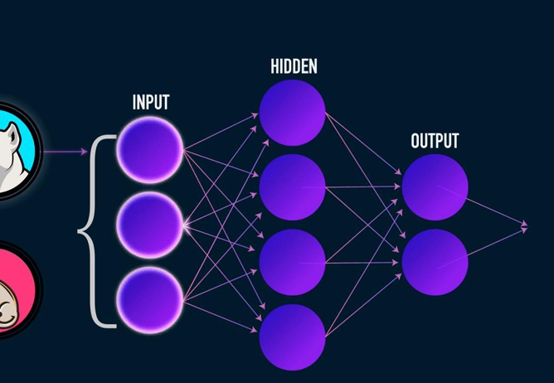

Neural Network Representations – ALVINN Example
ALVINN (Autonomous Land Vehicle In a Neural Network) is an early system that used an artificial neural network (ANN) to steer a self-driving car. The input to the network was a 30×32 grid of pixel intensities from a forward-facing camera. The output was the steering direction.
The network had:
- An input layer with 960 units (30×32 pixels),
- A hidden layer with 4 units,
- An output layer with 30 units, each corresponding to a possible steering direction.
Each hidden unit received input from all pixels and passed its output to all output units. The unit with the highest output value indicated the recommended steering direction.
ALVINN was trained using supervised learning, mimicking human driving for 5 minutes. It used the backpropagation algorithm to adjust weights and could drive at 70 mph for 90 miles on public highways.
The network is a feedforward ANN, typical of many ANN architectures, where learning corresponds to finding the best weights for each connection.

When Neural Networks (ANNs)

1. Instances are represented by many attribute-value pairs
- Neural networks work well when input data has many features (e.g., pixels in an image).
- These features can be related to each other or independent.

2. Input values can be any real values
- Inputs do not have to be categories.
- Real numbers (like sensor values, pixel intensities) are acceptable.

3. The target function output may be discrete-valued, real-valued, or a vector
- Output can be:
  - A single value (e.g., 0 or 1),
  - A real number (e.g., speed),
  - A vector (e.g., multiple steering directions or combined actions).

4. The training examples may contain errors
- Neural networks are good at learning even when some training data is noisy or incorrect.

5. Long training times are acceptable
- Training may take from seconds to hours.
- Acceptable when accurate predictions are more important than quick training.

6. Fast evaluation of the learned target function may be required
- After training, predictions are made quickly.
- Useful in real-time tasks (e.g., ALVINN makes quick steering decisions while driving).

7. The ability of humans to understand the learned target function is not important
- The model is a black box—hard for humans to interpret.
- Useful when accuracy matters more than explainability.
.

